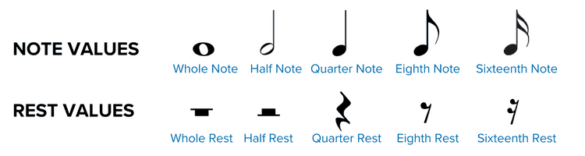

double whole note

whole note

half note

dotted note

quarter note

eighth note

duplet

triplet

quintuplet

sixteenth note

sextuplet

double whole rest

whole rest

half rest

quarter rest

eighth rest

sixteenth rest

thirty-second rest

sixty-fourth rest

one hundred and twenty-eighth rest

